
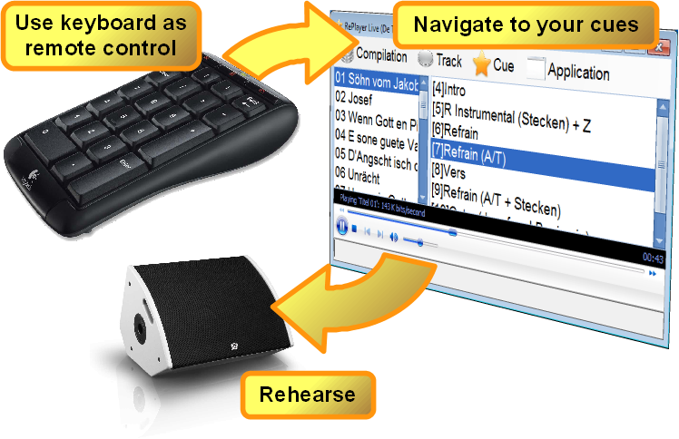
Replayer Version 0.4.1
Replayer is a free media player for use during rehearsals with playback music. It's main feature is fast navigation to predefined cue points in the playback media.

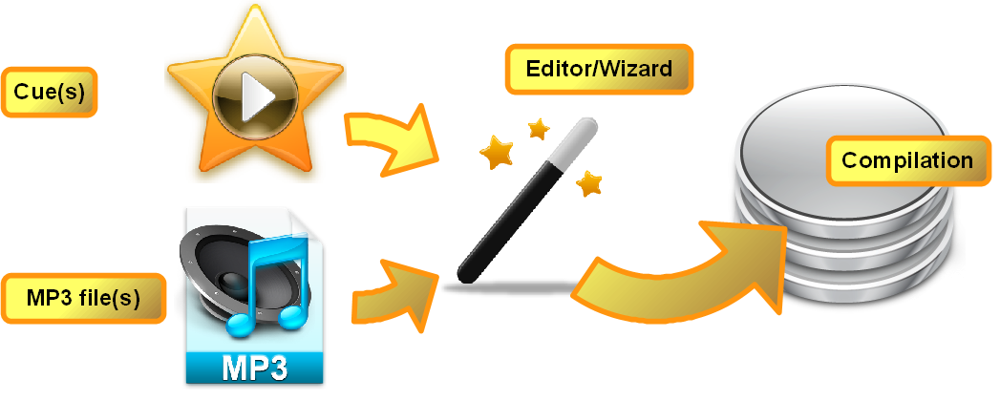
Getting started
First, you create a compilation of tracks and cues once, using a wizard from within Replayer.

Rehearse
Then, using Replayer and your laptop computer, you can rehearse any portion of your set with ease.

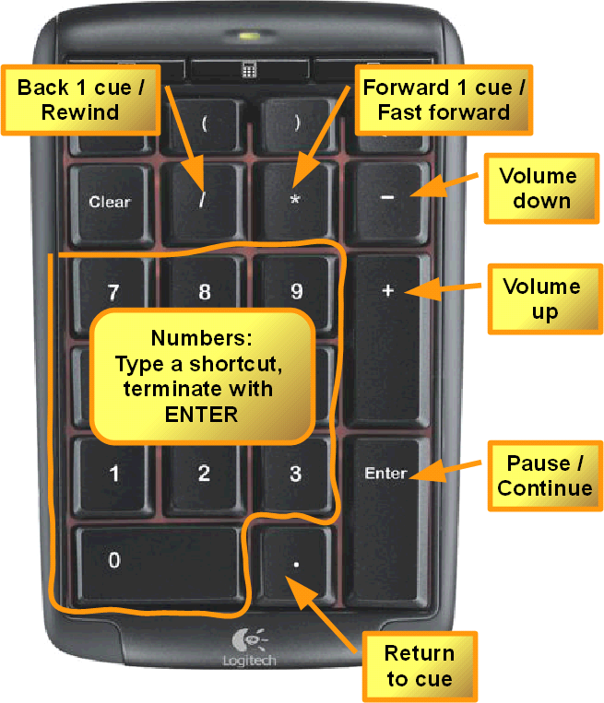
Fast
Use the navigation features on the numeric keypad.

Get your free copy today from http://replayer.codeministry.ch

